Assembling instruction

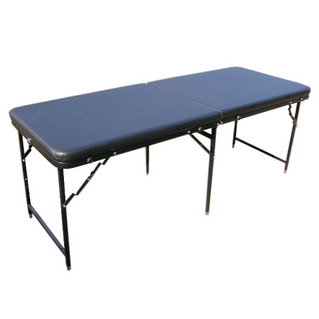

Model No.：T008
Specification:1820x690x680—850mm
Foam thickness:4cm
PVC color:blue
G.W.:19KGS
N.W.:16KGS
Working Load:250kgs

Assembling instruction:
Step 1st
:Open the carton,take the table from the carton
Step 2nd,
Open the folded table and undraw the legs
Step 3rd,
Pls use the table now

